ASSESSMENT 7

*“DATA CLEANING & DATABASE SCHEMA”*



Submitted By

VAIBHAV PATIDAR

IPS ACADEMY, INDORE (M.P.)

**Date :** 11-12-2023 | Monday

**Week 2** | **Day - 01**

For Query Only (File) : [**CLICK HERE**](https://docs.google.com/document/u/0/d/1dCtwVyBCszCtT75OwUJ_ckJ-LpBKBDDaOThg3ItVKeY/edit)

**What Is Data Cleaning?**

The process of data cleaning (also called data cleansing) involves

identifying any inaccuracies in a dataset and then fixing them. It’s the first

step in any analysis and it includes deleting data, updating data, and

finding inconsistencies

**Data Cleaning on Employee Table :**

**→ Creating an employee table :**

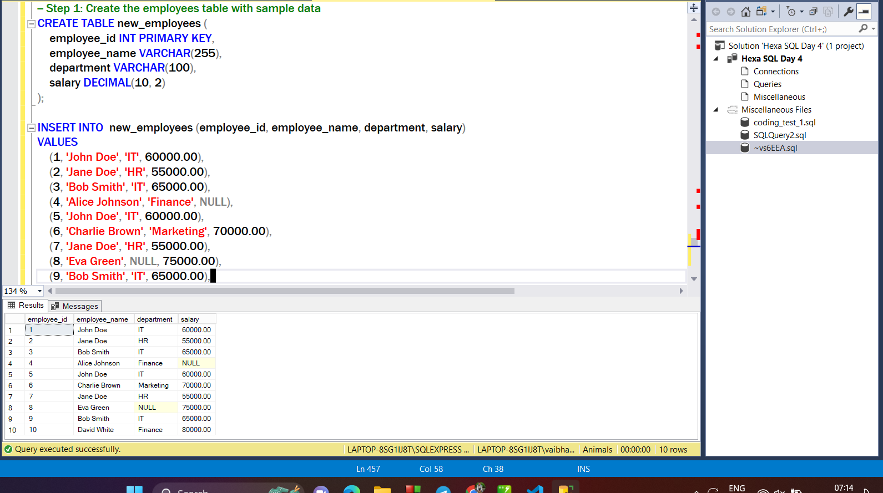

**→Deleting the duplicate values :**

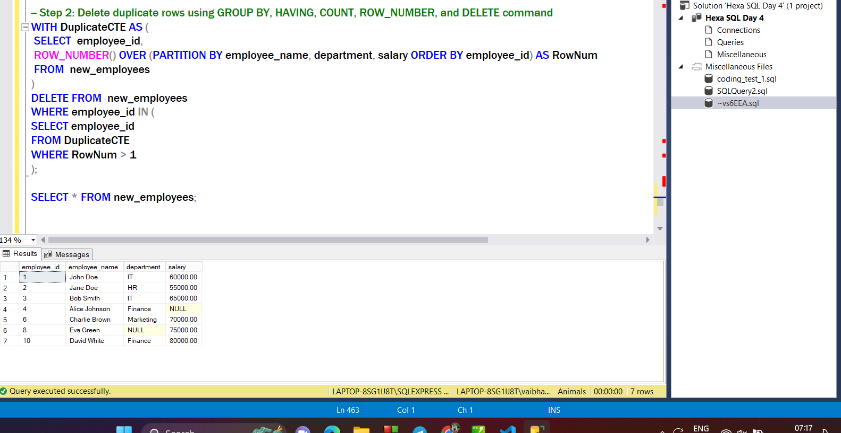

**→ Arranging the data in an order according to the employee_id :**

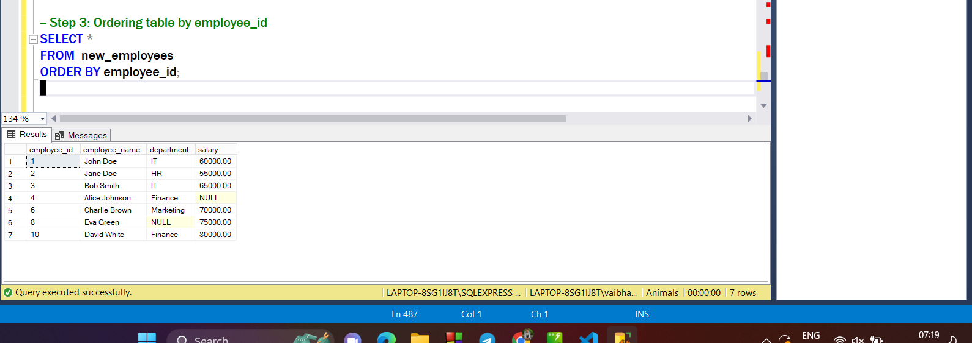

**→ Updating the NULL values in the table :**

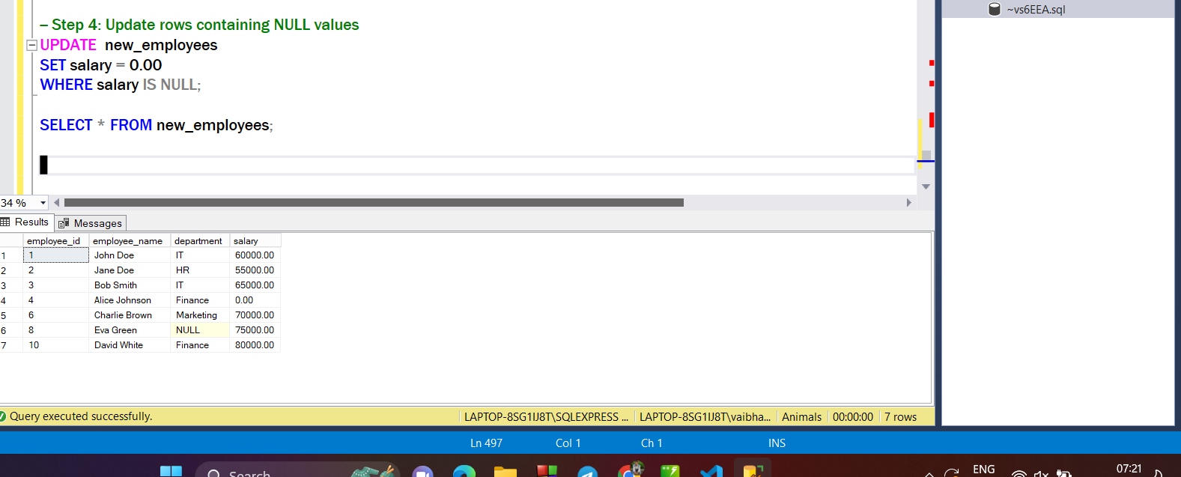

**→ Displaying the final cleaned output :**

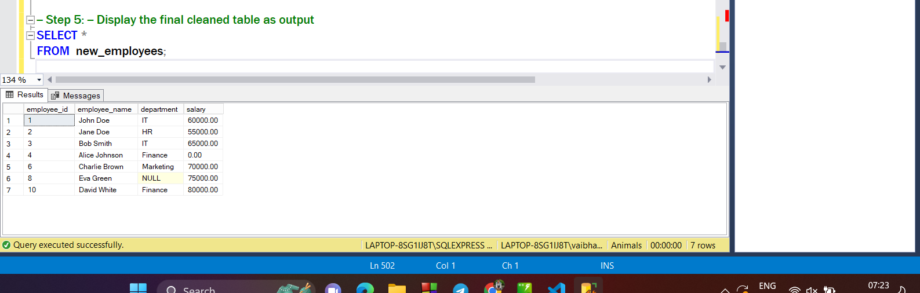

**What Is Database Schema?**

* A database schema is a blueprint or structure that defines the organization of data within a database.
* It outlines how data is organized into tables, specifying the fields, data types, relationships, and constraints.
* Describes the tables in the database, including the columns (fields) each table contains.
* Defines how tables are related to each other, establishing connections between different pieces of data.
* Enforces rules to maintain data integrity, such as unique keys, primary keys, foreign keys, and checks.
* Specifies the type of data that can be stored in each column, like integers, strings, dates, etc.

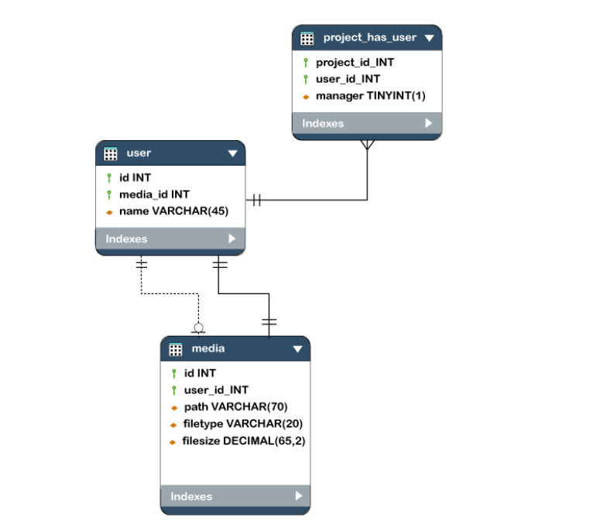

**Types of Database Schema**

1. Logical Schema
2. Physical Schema
3. View Schema

**Database Schema Designs**

1. Flat Model
2. Hierarchical Model
3. Network Model
4. Relational Model
5. Star Schema
6. Snowflake Schema

**STAR SCHEMA EXAMPLE :**

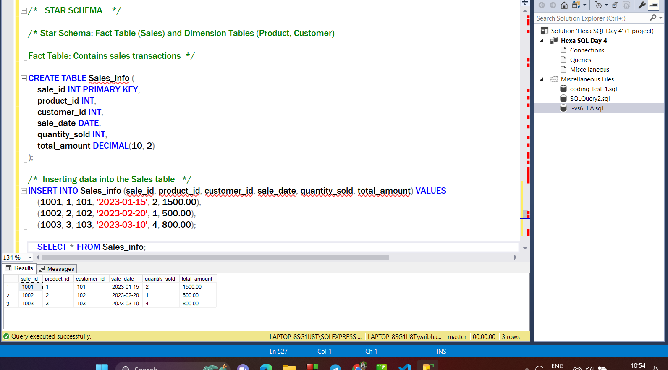

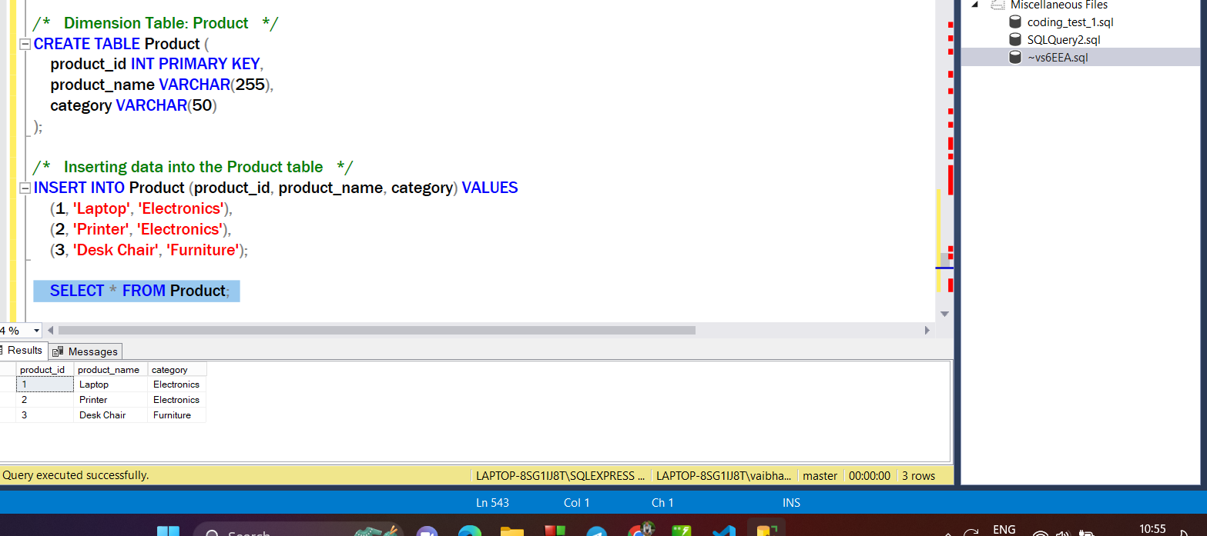

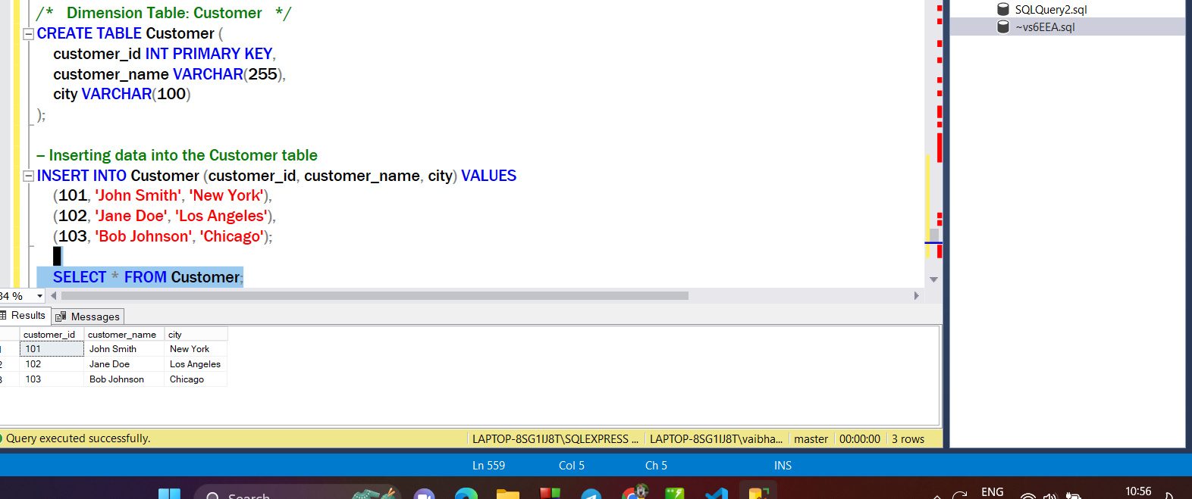

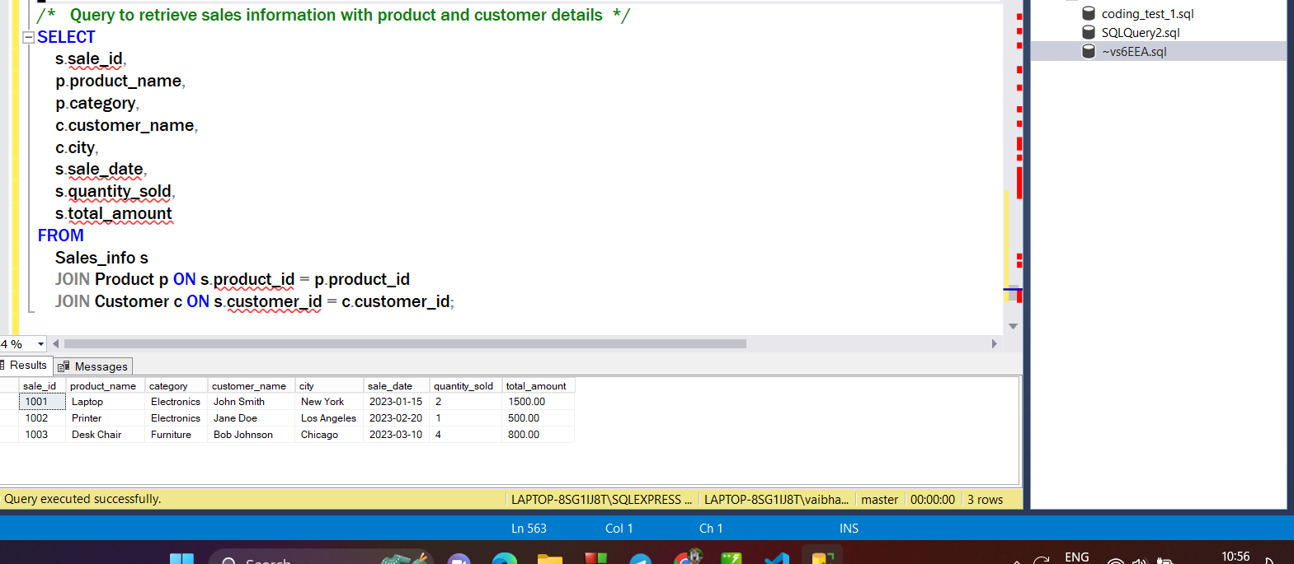

**SNOWFLAKE SCHEMA :**

